

**THE UNIVERSITY OF TEXAS AT ARLINGTON, TEXAS  
DEPARTMENT OF ELECTRICAL ENGINEERING**

**EE 5327 - 001**

**SYSTEM IDENTIFICATION & ESTIMATION**

**HW # 6**

**ASSIGNMENT**

**by**

**SOUTRIK MAITI**

**1001569883**

**Presented to**

**Prof. Michael Niestroy**

**Nov 28, 2017**

Problem 1:

MATLAB code for generating the training set for Fuzzy controller

clc

close all

w=0;

wk=[0.5 1.0 1.5 2.0 2.5 3.0];

t=0;

i=0;

nnin=zeros(1001,4);

for i=1:6

w=wk(i);

[t,y]=sim('Hw6P1a',[0 15]);

if i==1

nnin=NN_TrainData;

else

nnin=[nnin;NN_TrainData];

end

end

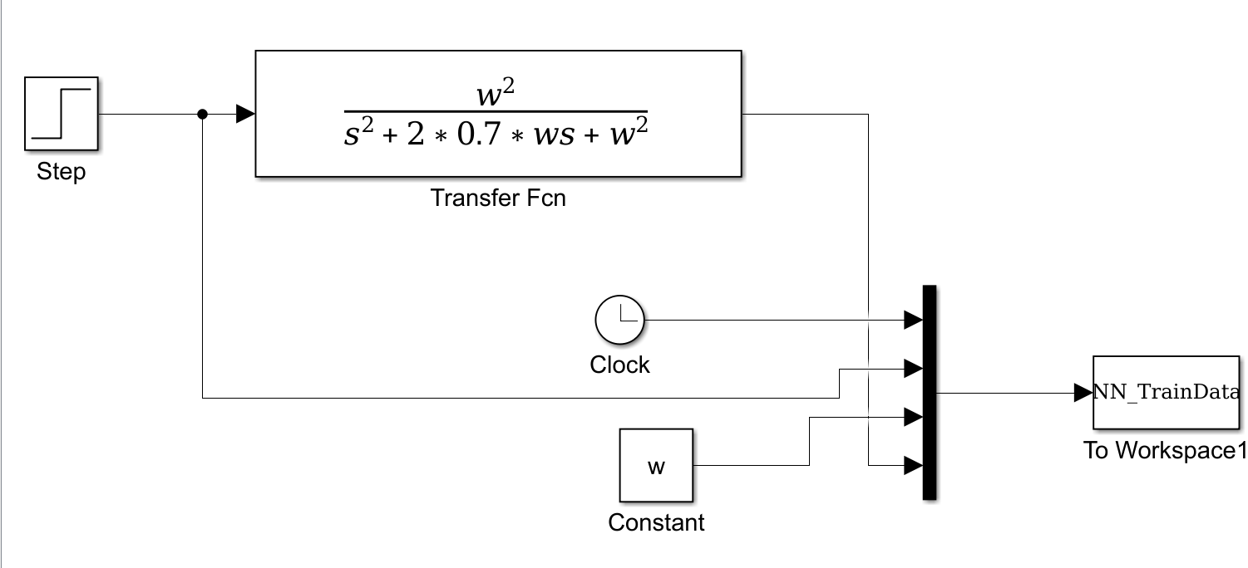

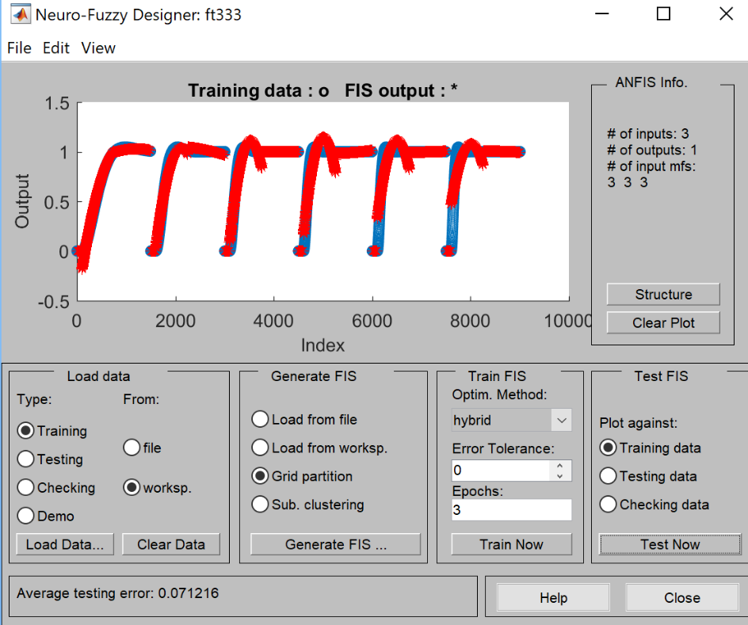

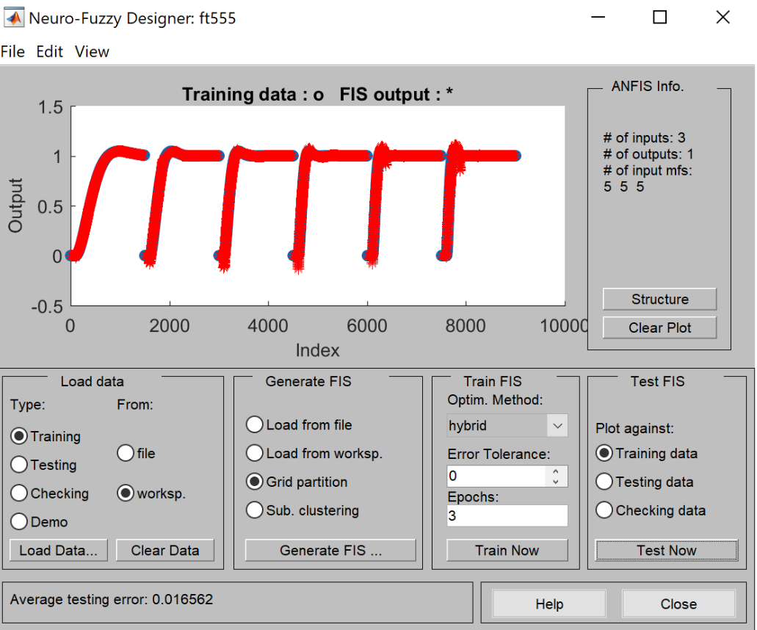

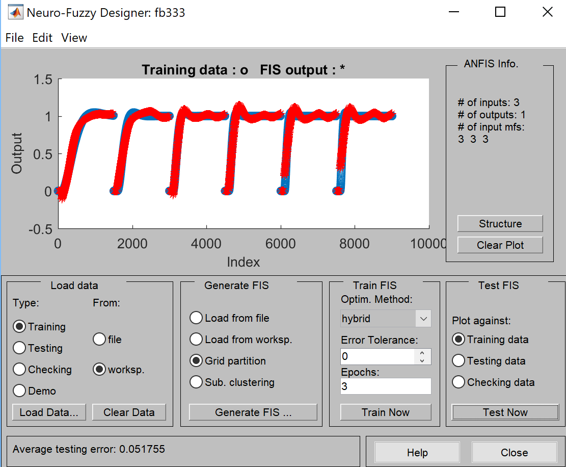

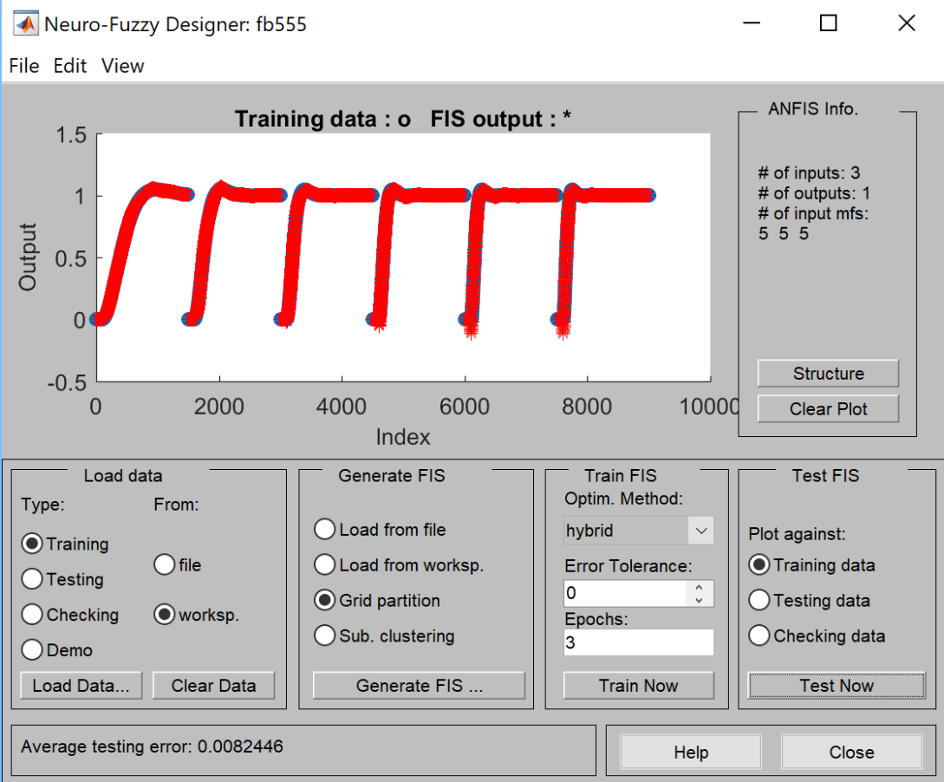

1. 3-3-3 with triangular membership functions and linear output

*Final Error = 0.071216*

2. 5-5-5 with triangular membership functions and linear output

*Final Error = 0.016562*

3. 3-3-3 with generalized bell membership functions and linear output

*Final Error = 0.051755*

4. 5-5-5 with generalized bell membership functions and linear output

*Final Error = 0.008245*

b) Comparison of training data & FIS output (zeta=0.7)

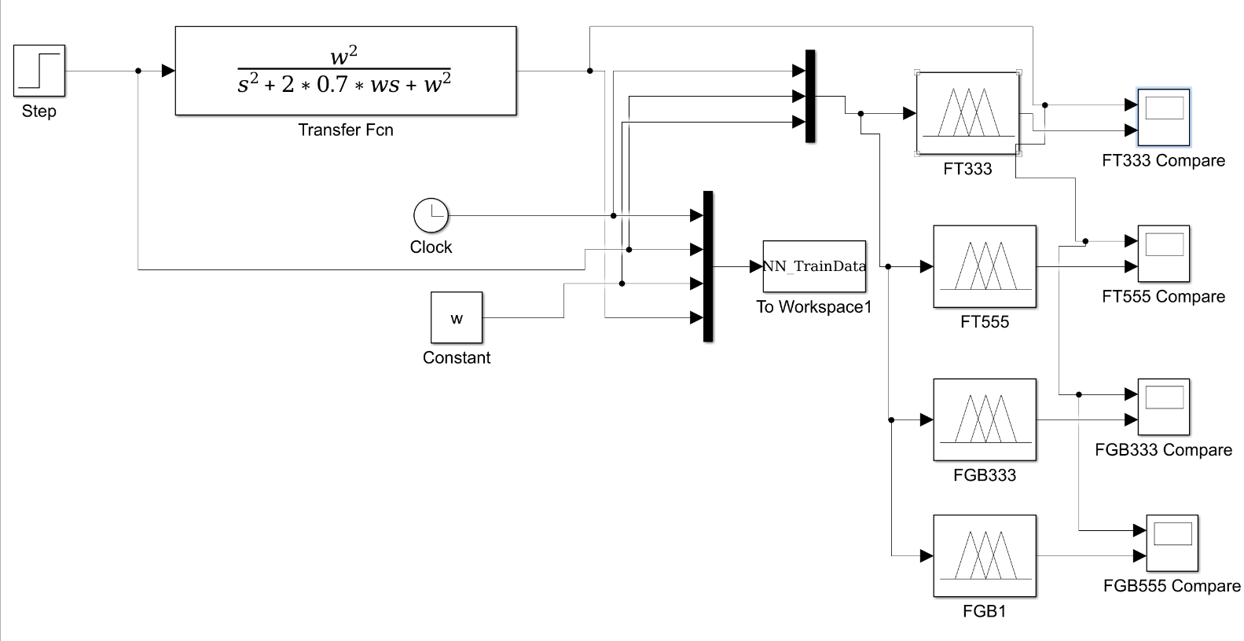

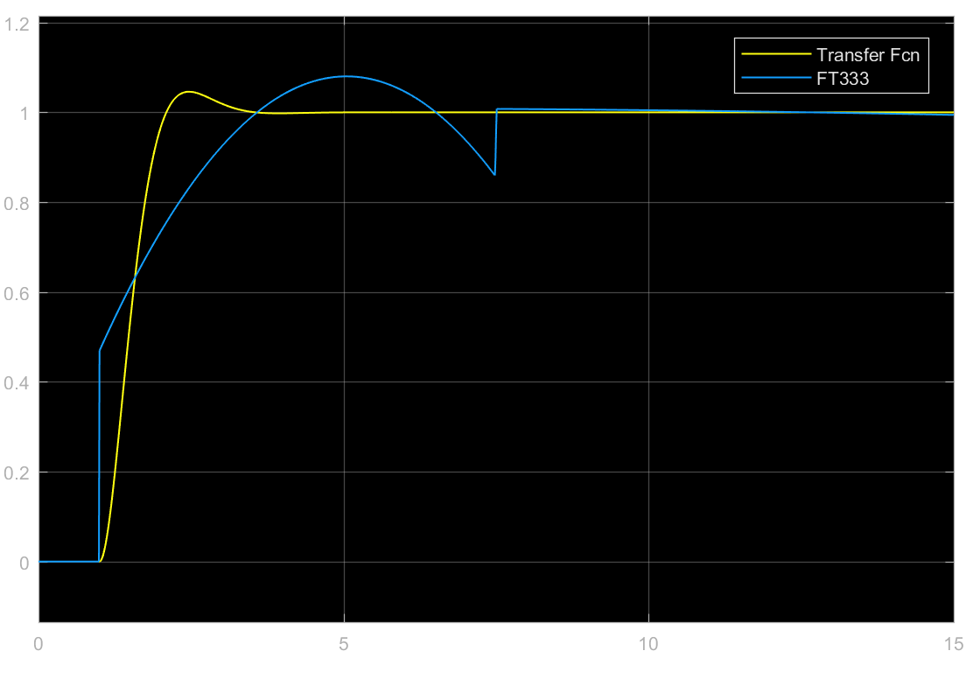

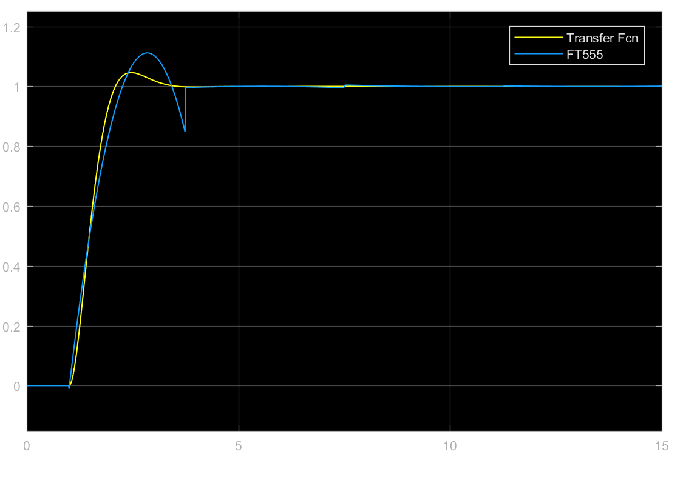

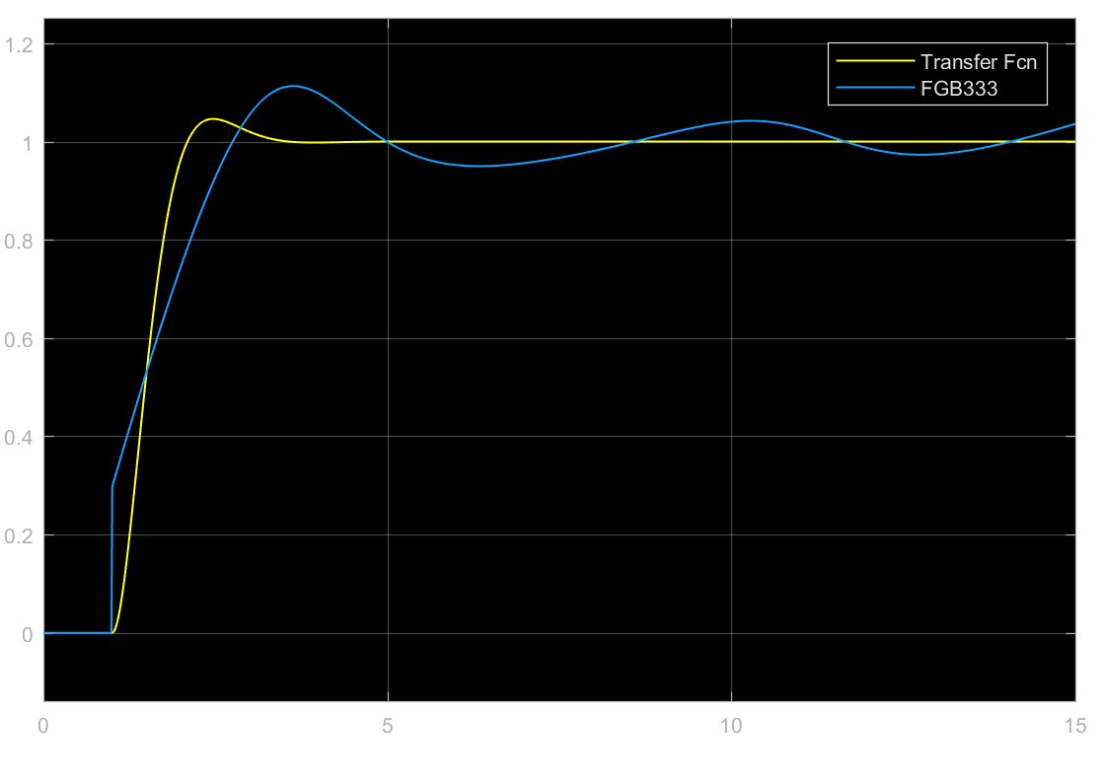

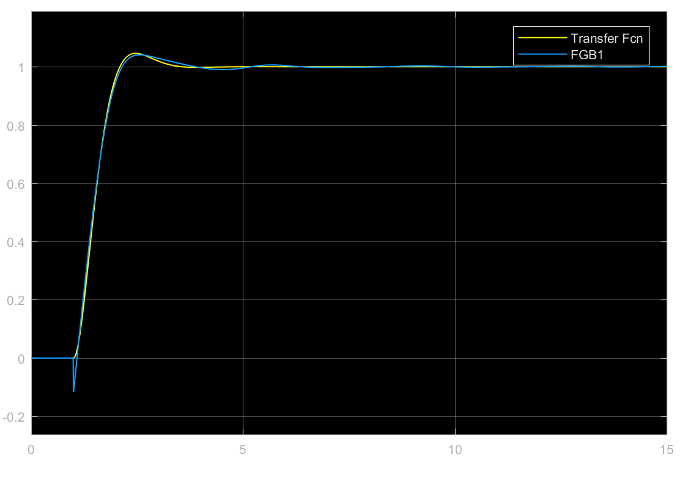

As per the comparison, the FIS with 5-5-5 generalized bell membership function is the closest to the training data at various values of w. Now, if we observe the error between the training data at ‘w’ value & the FIS output, we can see a clear difference in the accuracy of various types of FIS.

When w=0.75, the comparison and the error plots are as follows:

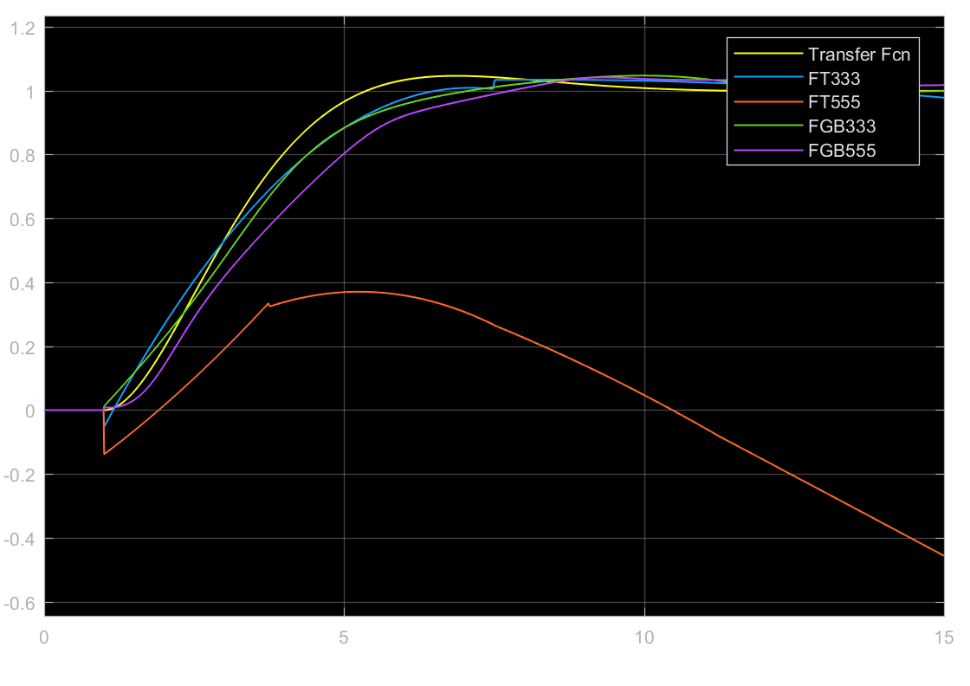

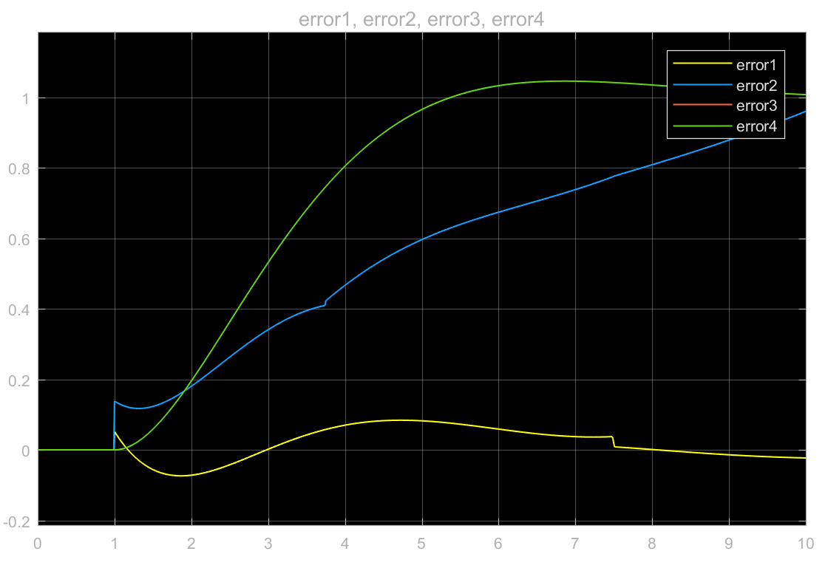

When w=1.25, the comparison and the error plots are as follows:

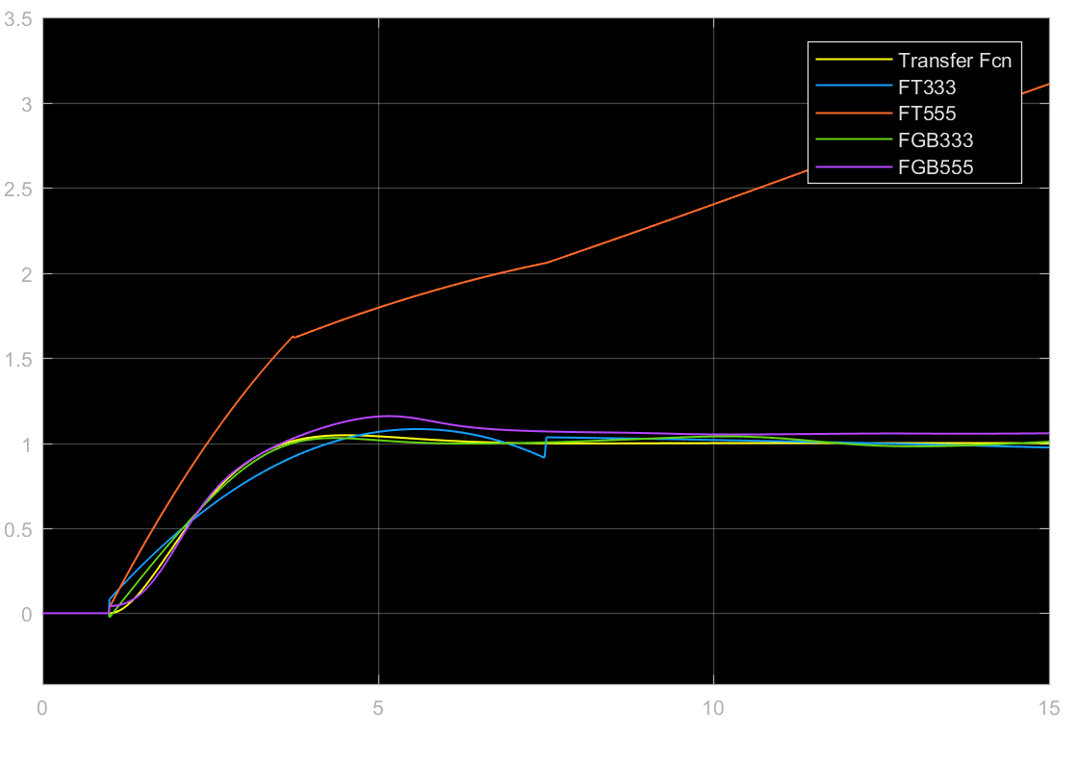

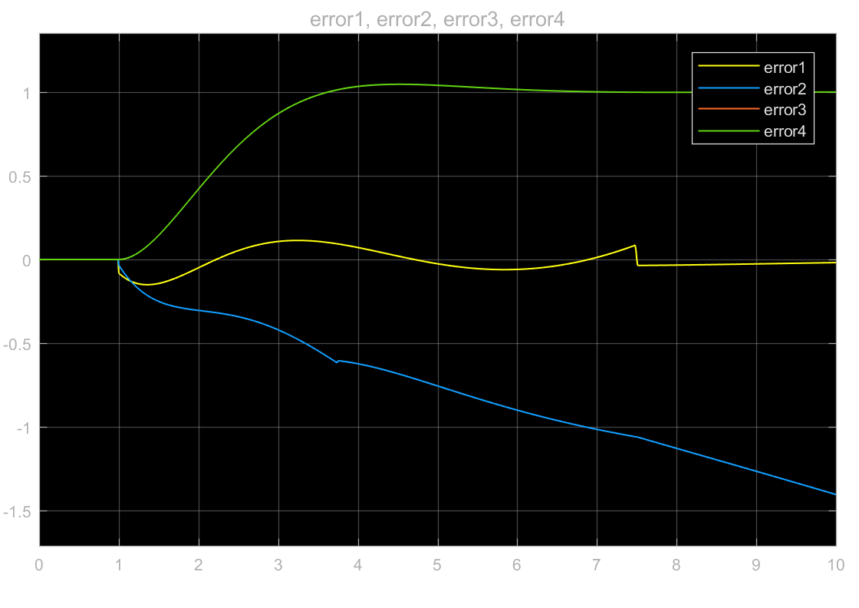

When w=1.75, the comparison and the error plots are as follows:

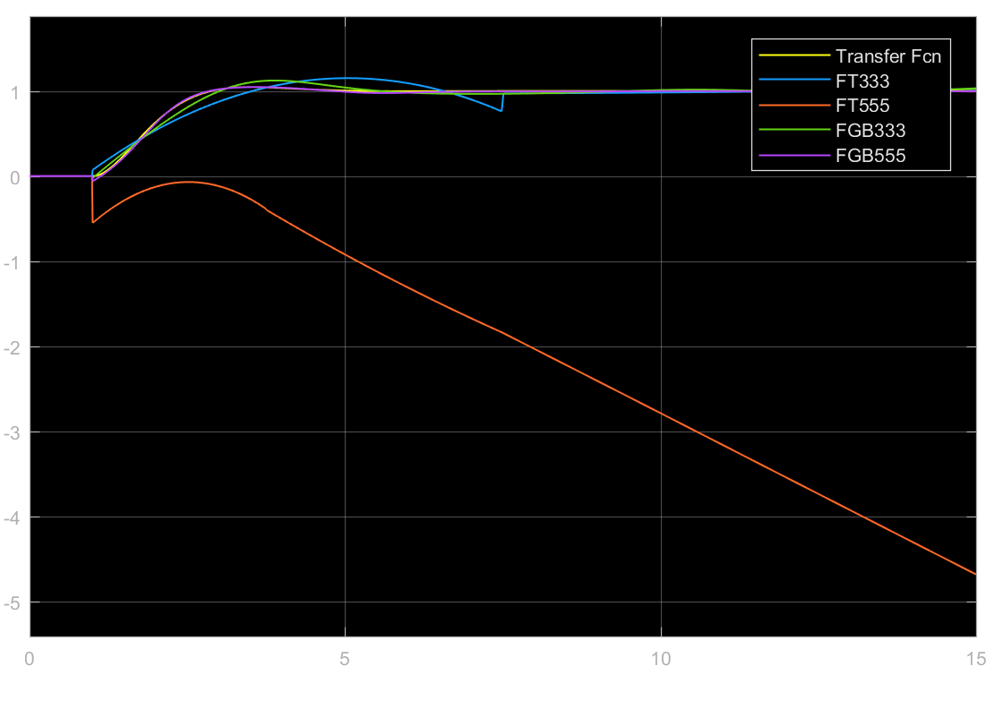

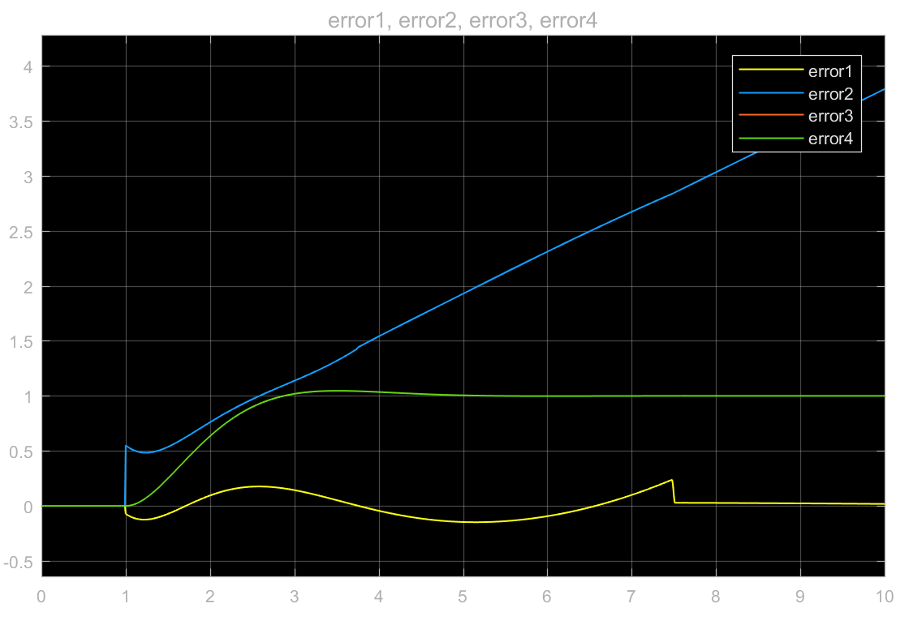

When w=2.25, the comparison and the error plots are as follows:

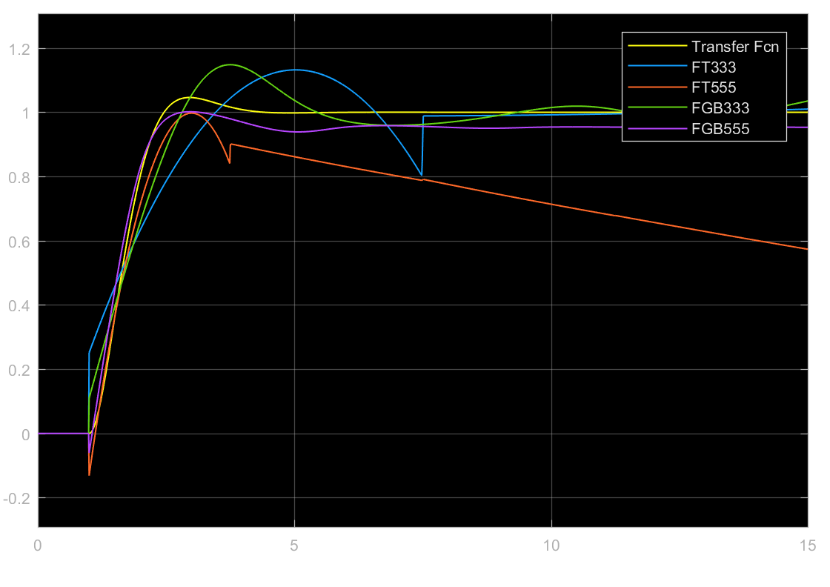

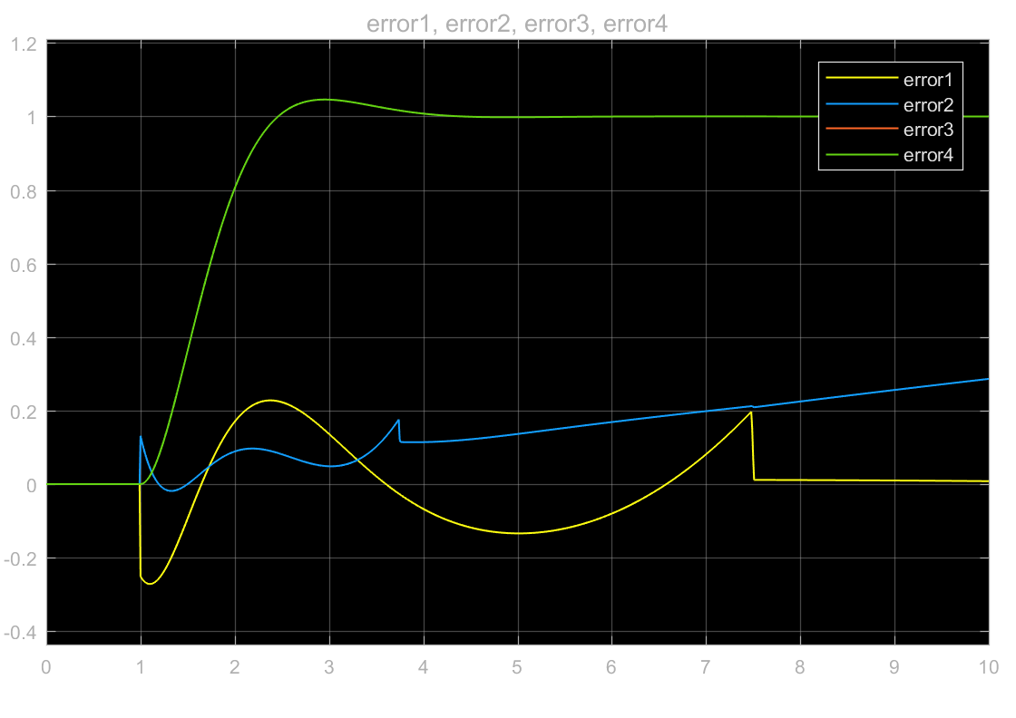

When w=2.75, the comparison and the error plots are as follows:

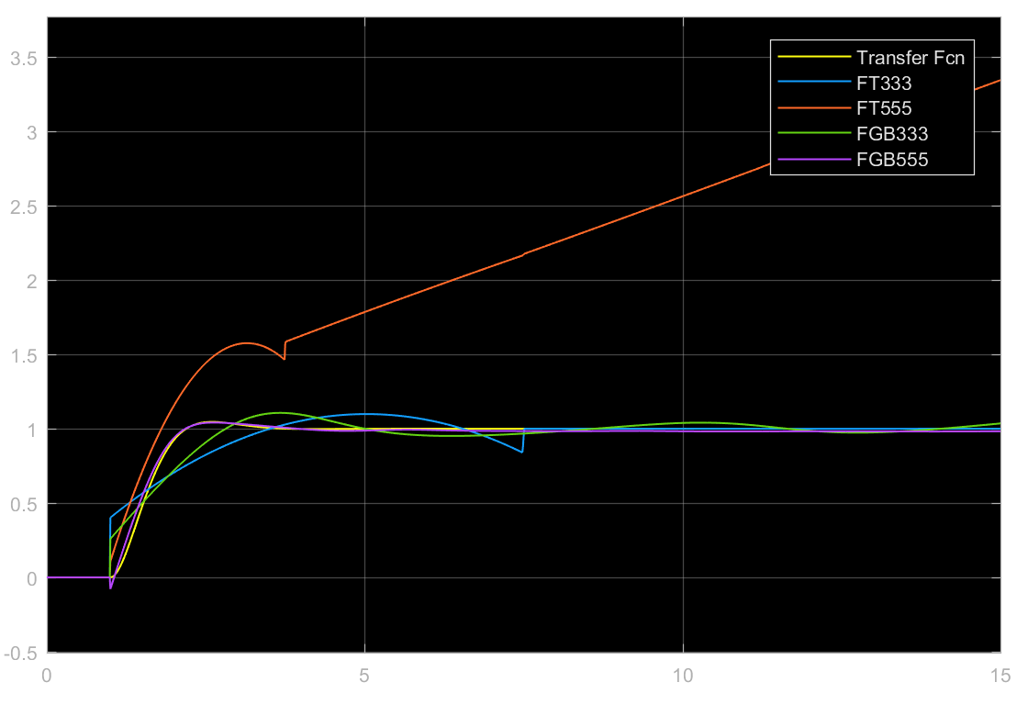

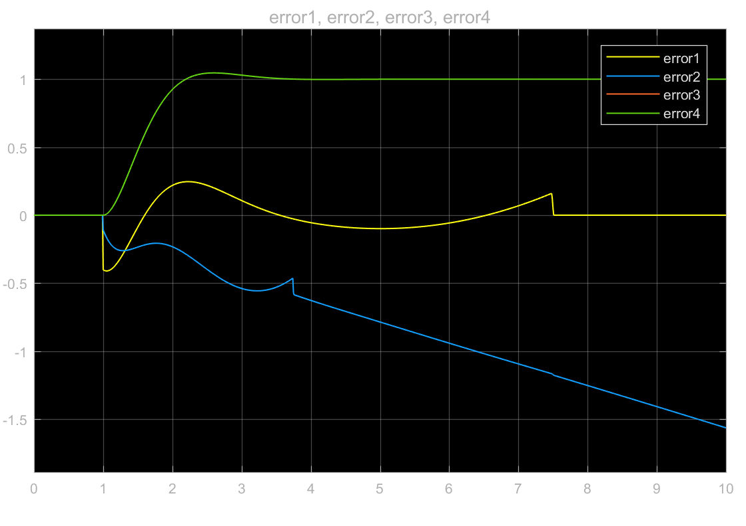

Generalized bell membership function (5-5-5) produces a pretty accurate estimate of the training data in all the different values of ‘w’.

d) For the application using a FIS to fit the training data works when using a Generalized bell membership function with linear output, the generalized bell membership function with 5-5-5 configuration is accurate with *0.008245* overall error.

Problem 2

MATLAB Code for Generating the data for the Fuzzy Controller

load mgdata.dat

a = mgdata;

time = a(:, 1);

x_t = a(:, 2);

trn_data = zeros(500, 5);

chk_data = zeros(500, 5);

% prepare training data

trn_data(:, 1) = x_t(101:600);

trn_data(:, 2) = x_t(107:606);

trn_data(:, 3) = x_t(113:612);

trn_data(:, 4) = x_t(119:618);

trn_data(:, 5) = x_t(125:624);

% prepare checking data

chk_data(:, 1) = x_t(601:1100);

chk_data(:, 2) = x_t(607:1106);

chk_data(:, 3) = x_t(613:1112);

chk_data(:, 4) = x_t(619:1118);

chk_data(:, 5) = x_t(625:1124);

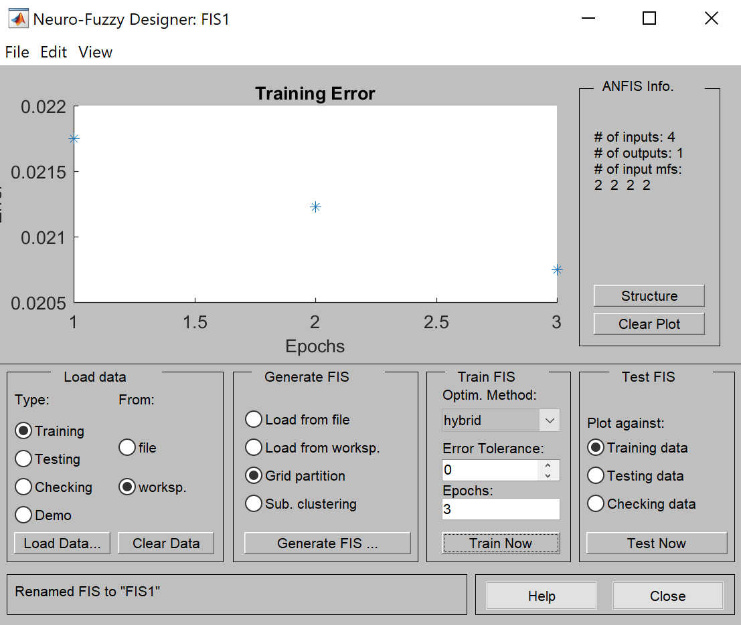

For sum squared error calculation:

%For sum squared error calculation

fis_data=evalfis(chk_data(:,1:4),FIS1);

error= chk_data(:,5)-fis_data;

plot(error);

xlabel('Time');

ylabel('Error');

title('FSTriangular');

%For sum squared error

sserror1=sum(error.^2)

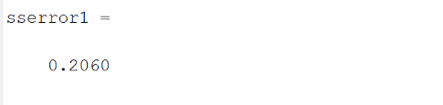

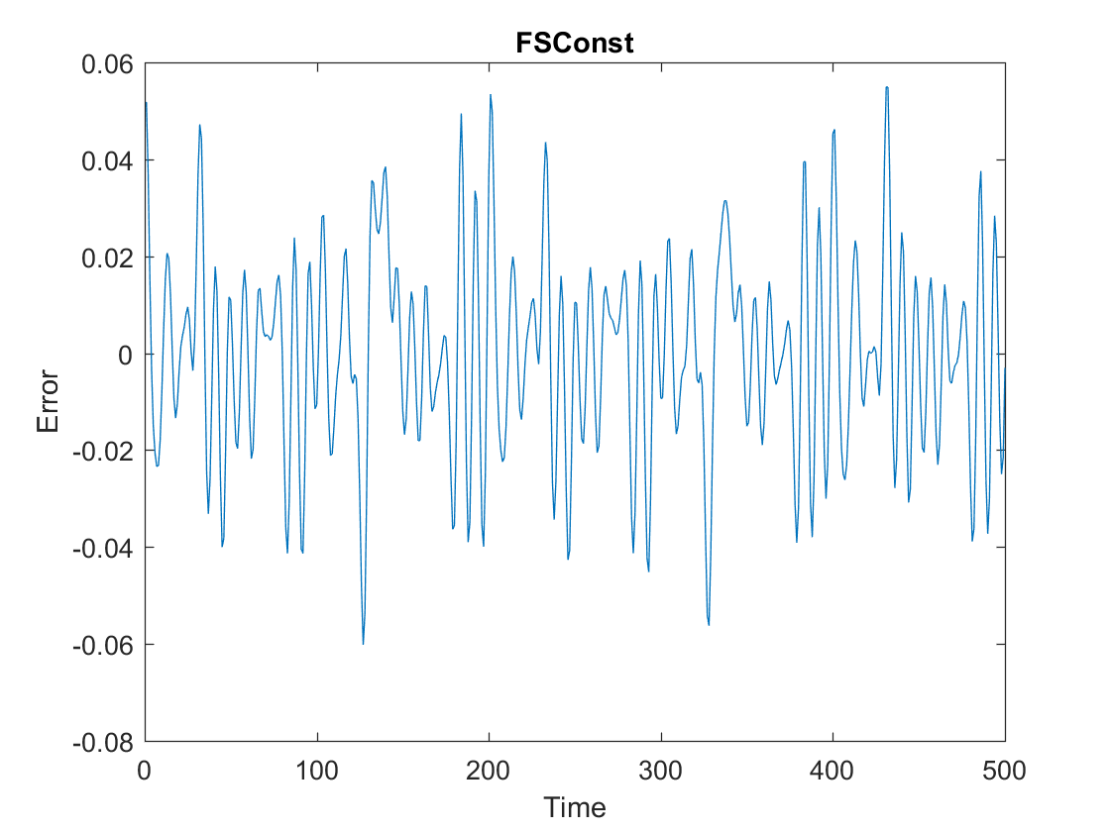

b) For Linear output membership function

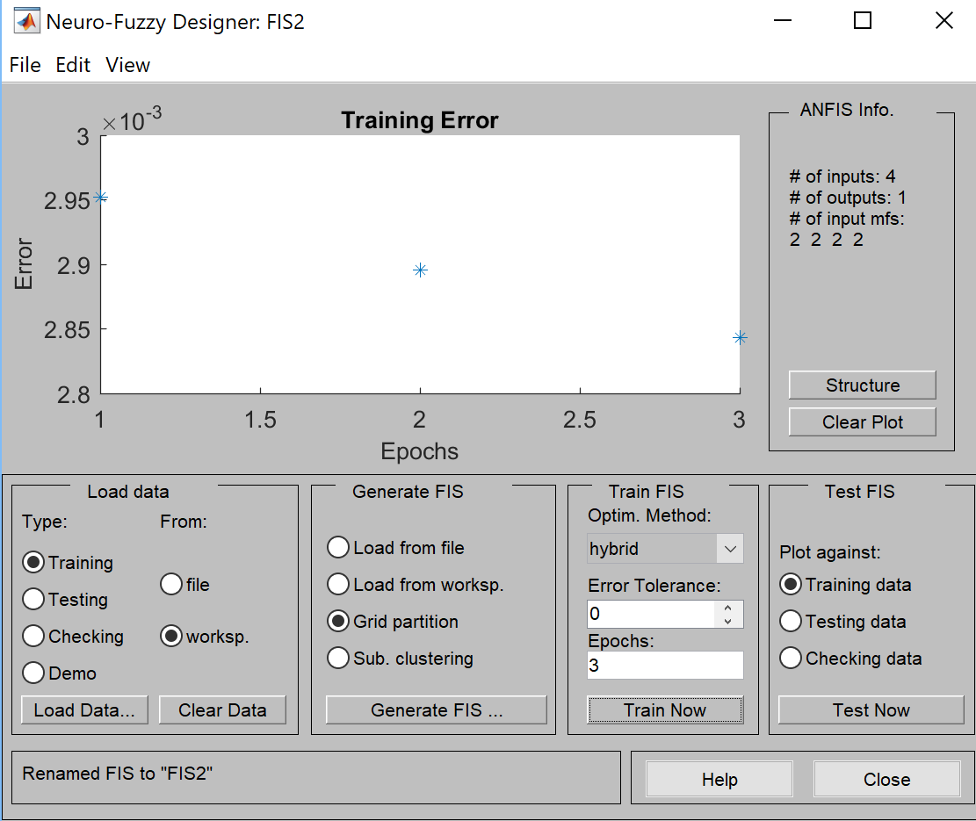

For sum squared error calculation:

%For sum squared error calculation

fis_data=evalfis(chk_data(:,1:4),FIS2);

error= chk_data(:,5)-fis_data;

plot(error);

xlabel('Time');

ylabel('Error');

title('FSLinear');

%For sum squared error

Sserror2=sum(error.^2)

Result:

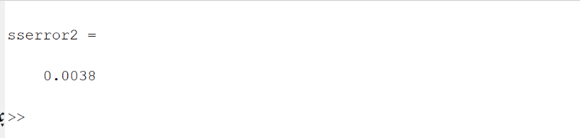

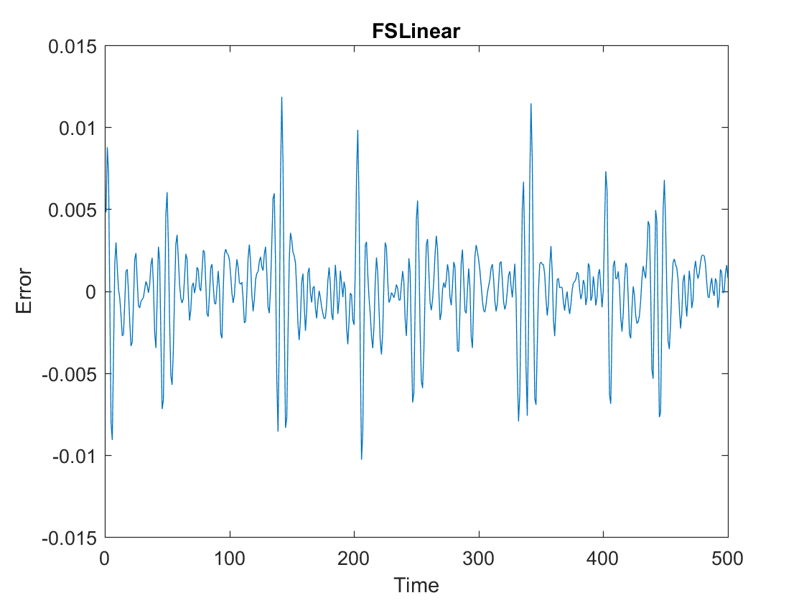

From the sum squared error value we observe that the FIS with linear output membership function has lower error as compared to the constant case. Hence, FIS with 2-2-2-2 Generalized bell membership function with linear membership function is better.

c) For Triangular Membership Function

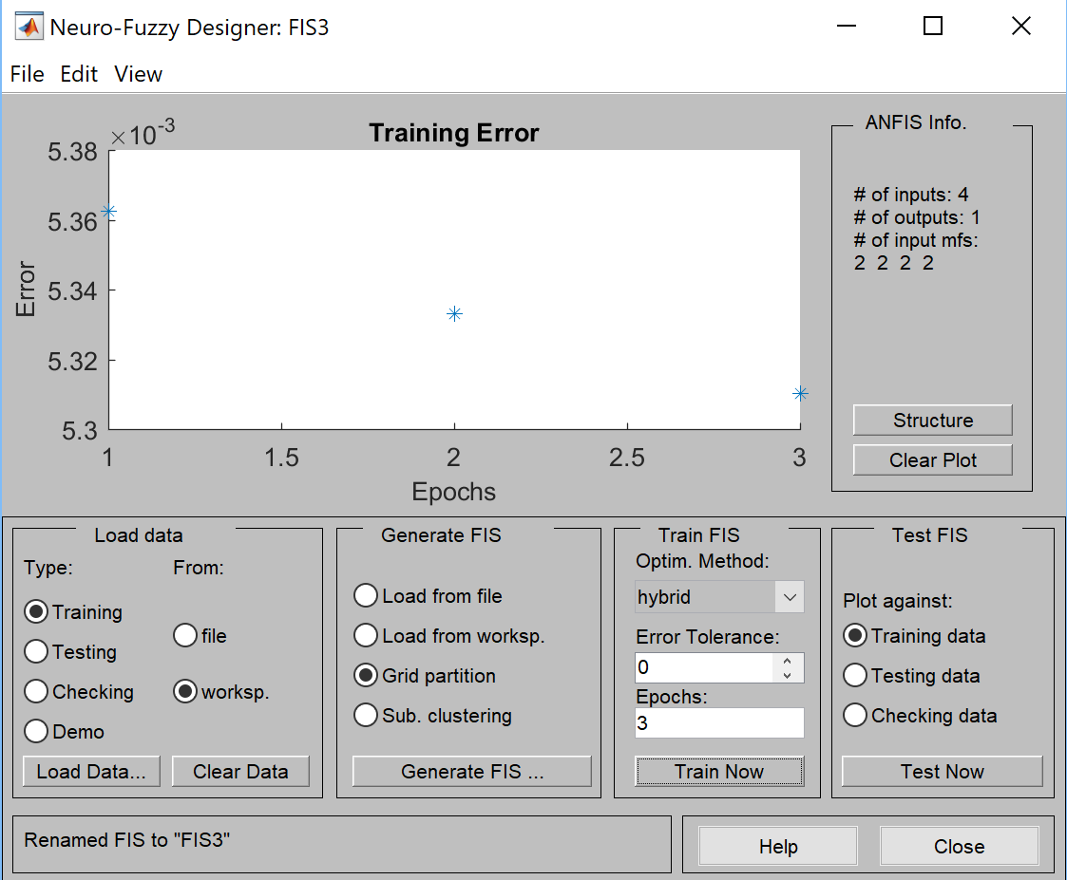

For Sum Squared Error calculation:

%For sum squared error calculation

fis_data=evalfis(chk_data(:,1:4),FIS3);

error= chk_data(:,5)-fis_data;

plot(error);

xlabel('Time');

ylabel('Error');

title('FSTrianguka');

%For sum squared error

sserror3=sum(error.^2)

Result:

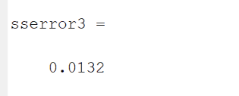

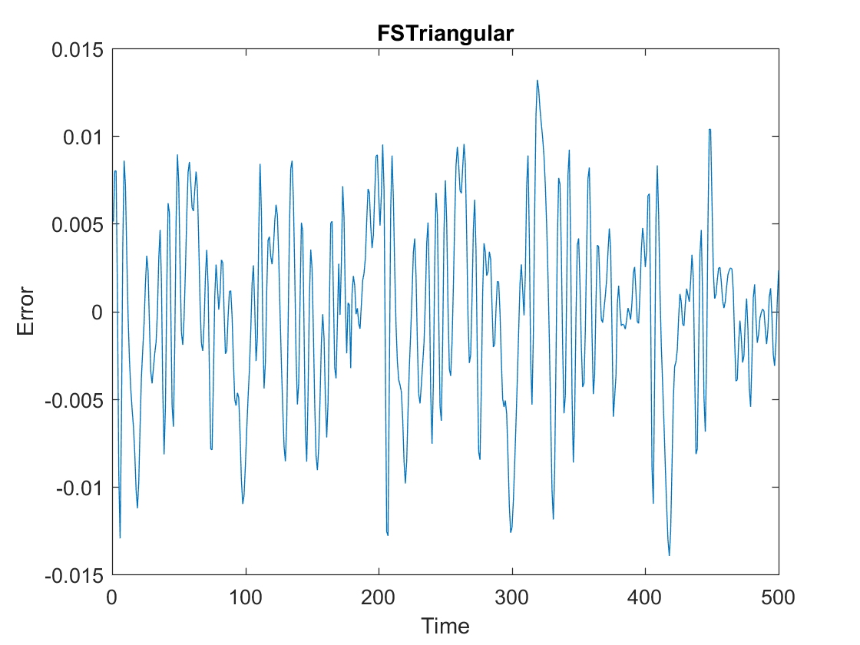

Thus, we can observe that the FIS with 2-2-2-2 Generalized bell membership function & linear output membership function has much lower error than the other two cases (sse = 0.0038) & is better as compared to the other two FIS.